- JUnit_Basic Testing Exercises
Dhruv Diguvapalli
diguvapallidhruv@gmail.com

Exercise 1: Installed Junit
Exercise 2, 3:
Calculator.java
package org.example;
public class Calculator {
public int add(int a, int b) {
return a + b;
}
public boolean isEven(int number) {
return number % 2 == 0;
}
public String getWelcomeMessage() {
return "Calculator Ready";
}
public String getErrorMessage() {
return null;
}
}

CalculatorTest.java
package org.example;

import org.junit.jupiter.api.Test;

import static org.junit.jupiter.api.Assertions.*;

public class CalculatorTest {

Calculator calculator = new Calculator();

@Test
void testAdd() {
assertEquals(5, calculator.add(2, 3));
}

@Test
void testIsEven_True() {
assertTrue(calculator.isEven(4));
}

@Test
void testIsEven_False() {
assertFalse(calculator.isEven(5));
}

@Test
void testWelcomeMessage_NotNull() {
assertNotNull(calculator.getWelcomeMessage());
}

@Test
void testErrorMessage_Null() {
assertNull(calculator.getErrorMessage());
}
}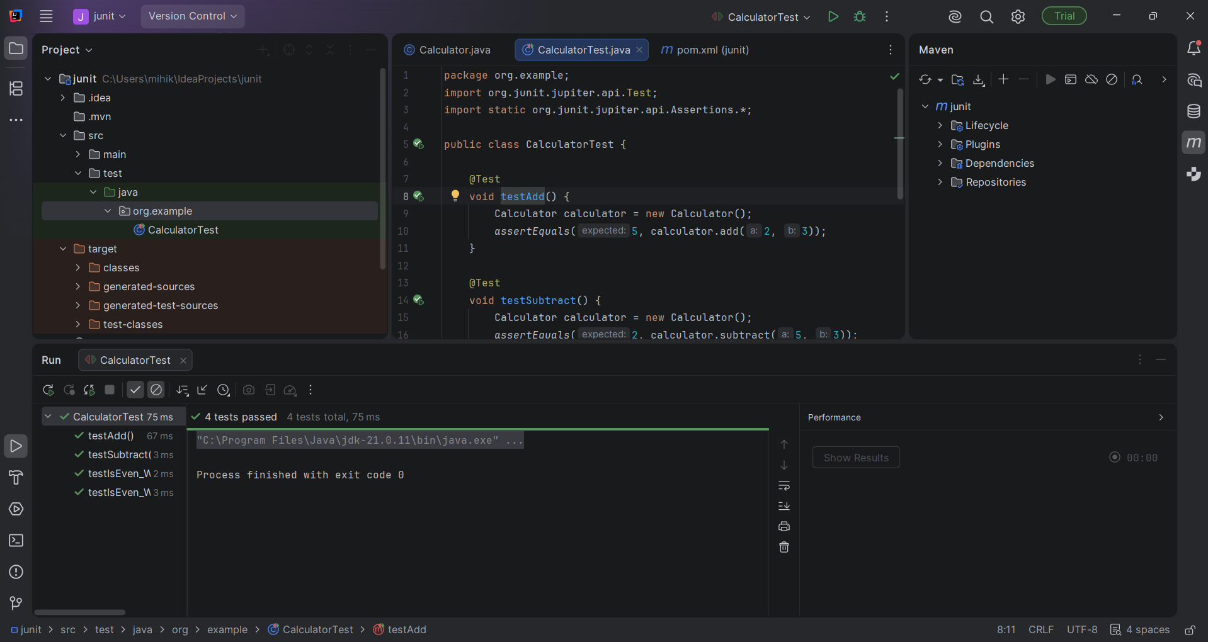

Exercise 4:
Calculator.java
package org.example;

public class Calculator {

public int add(int a, int b) {
return a + b;
}

public boolean isEven(int number) {
return number % 2 == 0;
}

public String getWelcomeMessage() {
return "Calculator Ready";
}

public String getErrorMessage() {
return null;
}
}

CalculatorTest.java
package org.example;

import org.junit.jupiter.api.AfterEach;
import org.junit.jupiter.api.BeforeEach;
import org.junit.jupiter.api.Test;

import static org.junit.jupiter.api.Assertions.*;

public class CalculatorTest {

private Calculator calculator;

@BeforeEach
void setUp() {
System.out.println("Setting up test...");
calculator = new Calculator();
}

@AfterEach
void tearDown() {
System.out.println("Cleaning up after test...");
calculator = null;
}

@Test
void testAdd() {

// Arrange
int a = 2;
int b = 3;

// Act
int result = calculator.add(a, b);

// Assert
assertEquals(5, result);
}

@Test
void testIsEvenTrue() {

// Arrange
int number = 4;

// Act
boolean result = calculator.isEven(number);

// Assert
assertTrue(result);
}

@Test
void testIsEvenFalse() {

// Arrange
int number = 5;

// Act
boolean result = calculator.isEven(number);

// Assert
assertFalse(result);
}

@Test
void testWelcomeMessageNotNull() {

// Arrange
// No special setup needed

// Act
String message = calculator.getWelcomeMessage();

// Assert
assertNotNull(message);
}

@Test
void testErrorMessageNull() {

// Arrange
// No special setup needed

// Act
String message = calculator.getErrorMessage();

// Assert
assertNull(message);
}
}
